Ideation Phase Define the Problem Statements
Date | 25 March 2026
Team ID | 69bf7f20c1eab70902258904
Project Name | Automating Data Import and Relationship Mapping Using Import Sets & Dot Walking
Maximum Marks | 2 Marks

1.Problem Description
The current data import process is largely manual and inefficient. Establishing relationships between tables (such as linking users to departments) is complex and prone to errors. Improper mapping leads to data inconsistency and affects overall system reliability.
2.Key Challenges
Manual data import increases time and effort
Difficulty in mapping relationships between tables
High risk of human errors during data entry
Inconsistent and unreliable data after import
Lack of automation in handling reference fields
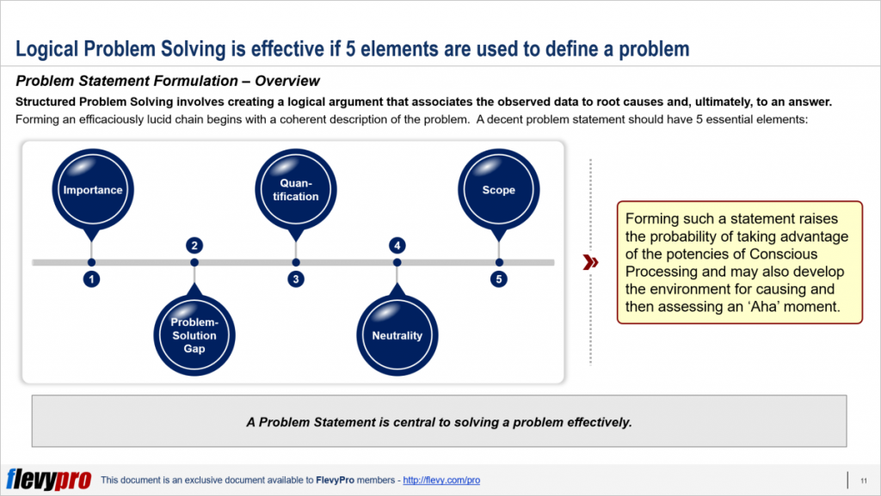

3.Problem Statement
Organizations face challenges in efficiently importing data and accurately mapping relationships between tables in ServiceNow. The existing process is time-consuming, error-prone, and lacks automation. Therefore, there is a need to develop a solution using Import Sets and Dot Walking to automate data import and ensure accurate relationship mapping.
4.Objective
To design and implement an automated system that simplifies data import and improves relationship mapping accuracy using Import Sets and Dot Walking techniques.

